# A Flexible Email Client App

|  |  |
| --- | --- |
| **Team Members** | **NM Id** |
| R.Chandhar | 01DA9CD11A2317A8CE7411956DCCB0A0 |
| E.Dhasaravi | 06AE072CC7147E180DD4732944F8CE56 |
| J.Madhan | E3011AE5BF0354EAE7145CEFA0688F93 |
| R.Vignesh | 7F7D045064E713383D04BF4169782CAC |

**Creating New Project:**

## Step1: Open Android Studio:

Launch Android Studio on your computer.

## Step2:Start a New Project:

On the welcome screen, click "Start a new Android Studio project".

# Screen Shots:

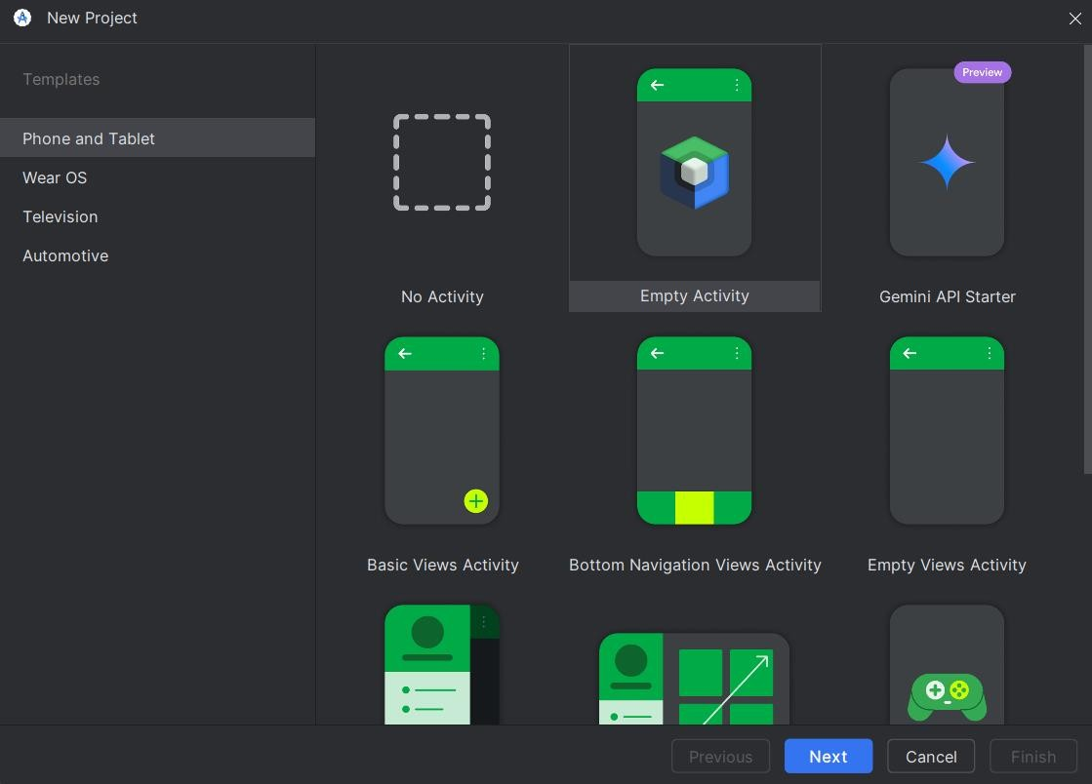

## Step3:Configure Your Project:

* **Name:** Enter your app's name.
* **Package Name:** Enter a unique identifier (e.g.,

`com.example.myapp`).

* **Language:** Choose between Java or Kotlin.
* **Minimum SDK:** Choose the lowest Android version your app will support.

## Step4:Choose a Template:

Select a project template (e.g., “Empty Activity”for a simple starting point), then click “Next”.

## Step5: Configure Activity:

* **Activity Name:** Default is `MainActivity` (you can change it).
* **Layout Name:** Default is `activity_main.xml`.

## -Click “Finish”. Step6:Run the App:

Once the project is set up, click the “Run”button to launch the app on an emulator or a physical device.

## Screen Shots:

